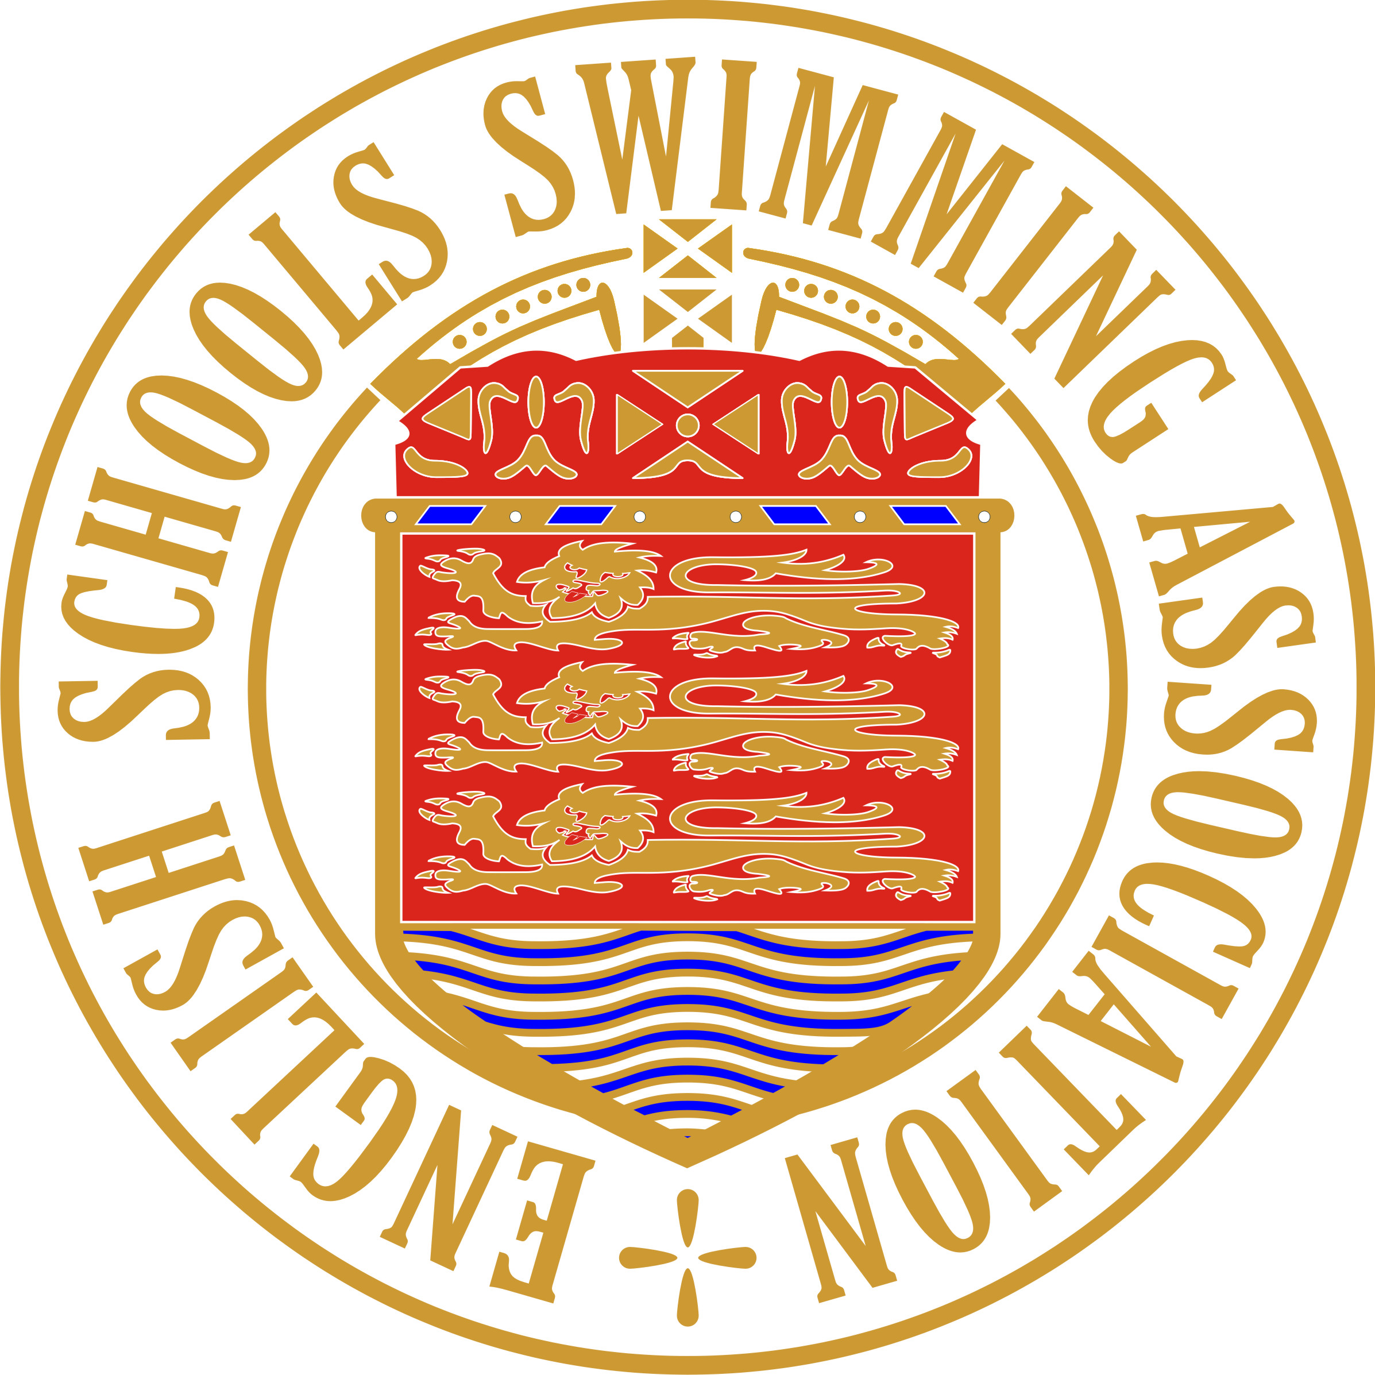NATIONAL SWIMMING CHAMPIONSHIPS

FOR SECONDARY SCHOOLS

RELAYS

TEAM LIST – DIVISIONAL ROUND 2026
Date:
Venue:

Full School Name:
Division: EM

Relay Event  4 x 50m | Mixed  Medley | Mixed  Freestyle | Girls  Medley | Girls  Freestyle | Boys  Medley | Boys  Freestyle
Junior
(born 01/09/13– 31/08/15) Yr 7 & 8
Intermediate
(born 01/09/11 – 31/08/13) Yr 9 & 10
Senior
(born 01/09/08 – 31/08/11) Yr 11,12 & 13

 | FULL NAME  (PLEASE USE BLOCK CAPITALS) | Date of Birth | School  Year
1
2
3
4
Reserve

I certify that the dates of birth of team members given above have been checked in the School
Admission Register and that all the conditions of the Championships have been observed.

Signature Date
(Teacher in charge)

PLEASE NOTE: A team list MUST be completed and handed to the organiser, before the commencement of each round, by a representative of the school.
Hand it in on the 25th September at the event.

A SEPARATE TEAM LIST MUST BE SUBMITTED FOR EACH EVENT

(Please photocopy the number required)

