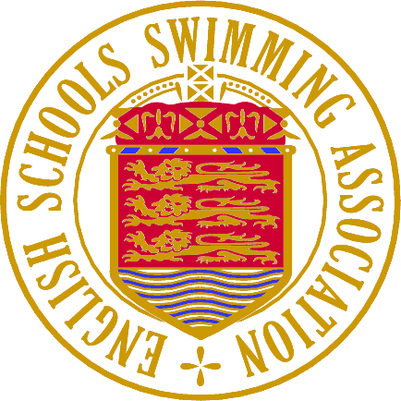
Patron: HRH The Prince of Wales
National Primary Team Championships 2026
Team Merchandise
Team Merchandise

School Name:
Person completing order:
Contact details:

T-Shirt Number | School Logo  (Yes/No) (extra £3.00 per t-shirt) | Customised Text  e.g. Swimmer/School Name  (extra £3 per t-shirt) | T-Shirt Size  (See size guide for chest sizes)  (Age 7-8, Age 9-11, Age 12-13, Adult S, M, L, XL)
1
2
3
4
5
6
7
8

Quantity | Item |  | Totals
 | CHILD: Standard T-Shirt | £19 each | £
 | ADULT: Standard T-Shirt | £25 each | £
 | EXTRAS: School logo | £3 per t-shirt | £
 | EXTRAS: Customised Text | £3 per t-shirt | £
T-Shirt Total to pay: |  |  | £

*Personalised Hoodies: Oxford Navy/Hot Pink – NAME ONLY*
Hoody Number | Customised Text  e.g. Swimmer/School Name  (extra £3.00 per t-shirt) | Hoody Size  9-11 chest size 28-30, 12-13 chest size 30-32  Small – chest size 34-36, Medium – chest size 38-40 | Colour  Pink(P)/  Navy(N)
1
2
3
4
5
6
7
8

Quantity | Item |  | Totals
 | Standard Hoody | £40 each | £
 | EXTRAS: Customised Text | £3 per hoody | £
Hoody Total to pay: |  |  | £
If you want a plain hoody, please just indicate size and leave customised text blank.

Other Items available

Quantity | Item |  |  |  | Totals
 | ESSA Nationals Hat | Pink/Blue |  | £10.00 each | £
 | ESSA Nationals Towel |  |  | £25.00 each | £
Hats & Towels Total to pay: |  |  |  |  | £

Payment Summary:
Item | Totals
ESSA T-shirt total | £
ESSA Hoody total | £
ESSA other items total | £
Overall total: | £

Please save this form and then e-mail it
with your school logo, if necessary, to:

orders@essa-mail.uk

Closing date for personalised orders:
Sunday 7th June 2026
All orders will be acknowledged with an e-mail reply. All orders need to be pre-paid unless agreed in advance. Please note for non-personalised items a stock of all goods listed will be at the venue. Please arrive early to avoid disappointment.
Payment: This can be completed in 2 ways:
- By Stripe (0nline secure payment)- https://buy.stripe.com/aEU4jX6Mc4QmcBa4gq
- BACS payment.
Name: English Schools Swimming Association
Bank : Barclays (Southwark)
Bank Sort Code: 20-80-57
Account: 23491161
Ref: PTM26 + school name.
Please note all BACS payments must be received by Wednesday 17th June 2026.

