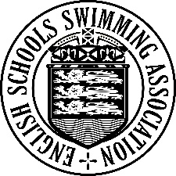
30th NATIONAL SWIMMING

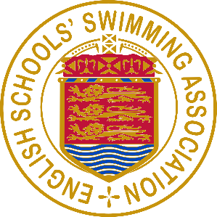
CHAMPIONSHIPS FOR

PRIMARY SCHOOLS 2026

TEAM LIST – DIVISIONAL ROUND

School:
Division: SW

 | 4 x 25m Freestyle Relay | 4 x 25m Mixed Stroke Relay
Open Schools Boys Team
Open Schools Girls Team
Large Schools Team
Small Schools Team

Event:
(Please tick relevant box)

 | FULL NAME  (PLEASE USE BLOCK CAPITALS) | DATE OF BIRTH  (from 1/9/2014 - 31/8/2016) | SCHOOL  YEAR
1
2
3
4
Reserve

Adult in charge, on the poolside:

I confirm that the above pupils are on the full-time roll of the above School and
that their dates of birth, as given above, are correct.

Signature Date
(Teacher in charge)

A SEPARATE TEAM LIST MUST BE SUBMITTED
AT EACH STAGE OF THE CHAMPIONSHIPS

THIS FORM, DULY COMPLETED, MUST BE HANDED IN TO THE RECEPTION TABLE AT THE SOUTH WEST DIVISIONAL GALA,
ON WEDNESDAY 25th MARCH 2026

